GitHub desktop manual

Introduction to GitHub:

GitHub is a web-based platform revolutionizing collaborative software development through Git version control. It organizes projects into repositories, providing tools like pull requests and issues for seamless collaboration. GitHub Desktop, its user-friendly companion, offers a graphical interface simplifying Git tasks for both beginners and seasoned developers. With features like visual branch management, easy commits, and syncing capabilities, GitHub Desktop streamlines the process of working with repositories, enhancing the overall efficiency of version control. Together, GitHub and GitHub Desktop form a powerful combination, empowering teams to manage projects, track changes, and facilitate smooth collaboration in the world of software development.

Cloning a repository:

1: after you open GitHub desktop click on file and clone repository and then URL. Should look like this:

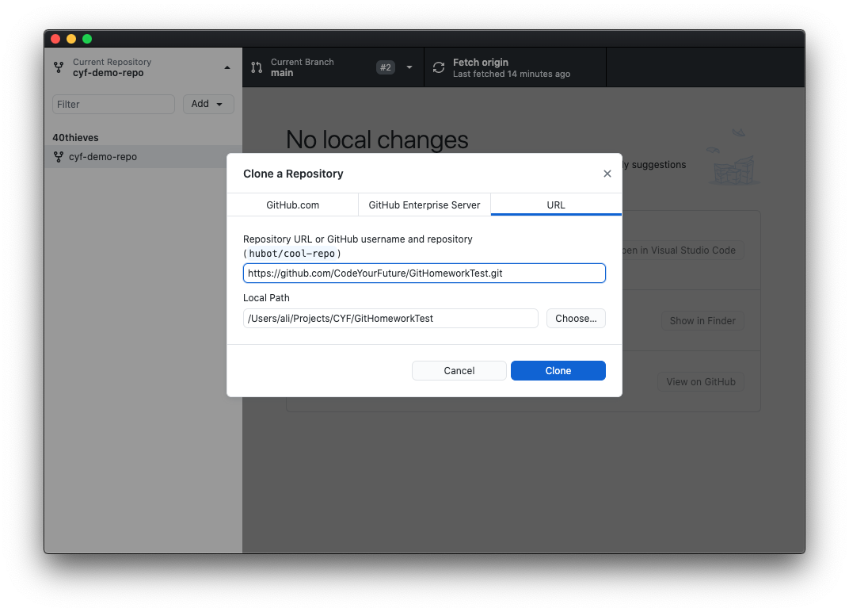

2: to find the URL open github.com and log in

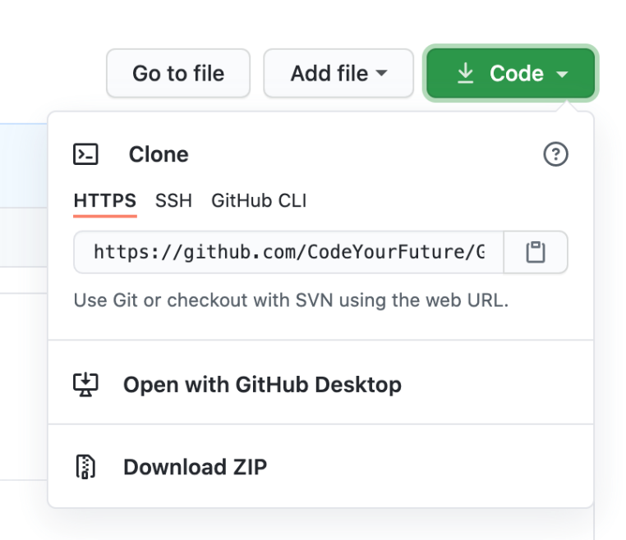3: find the repository you are looking for and then click the green code button: (should look like this)

4: copy the URL and paste it in GitHub desktop pick a folder on your computer where you want the repository to go and click clone and it should be done.

Creating a branch:

1: click on branch and new branch and then you can give your branch a name: (should look like this)

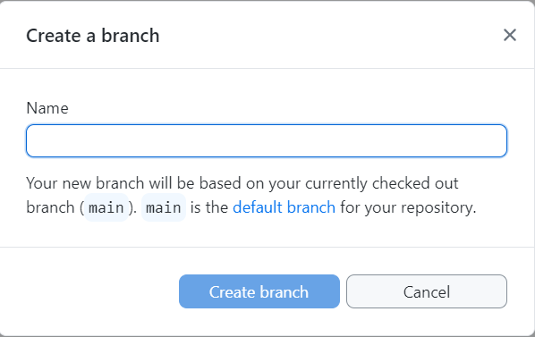

2: then you will see this screen

Mynd sem inniheldur texti, skj�mynd, n�mer

Lýsing sjálfkrafa búin til

where you can choose either leave changes on main or bring them with to the new branch, then if you want to move to the new branch, you click switch branch otherwise cancel.

3: finally, if you want other people to be able to access the new branch you click the publish branch button.

Committing changes and pushing to current branch, pull requests and merge conflicts:

1: after making changes to the repository, you want to push to your current branch.(

Mynd sem inniheldur texti, skj�mynd

Lýsing sjálfkrafa búin til

2: on the right you can see the changes you made in red and green. To commit, you write your commit message where it says update README.md and then press commit to “your branch”.

Mynd sem inniheldur texti, skj�mynd

Lýsing sjálfkrafa búin til3: then you press the “push origin” button.

4: to make the pull request you click on preview pull request and create pull request.

5: then you will be taken to GitHub.com where you press create pull request.

6: then they will tell you if there is a merge conflict to deal with, if there is no merge conflict you can merge the branches safely. If there is a merge conflict we need to deal with it

7: press “resolve conflict” then you should see a screen similar to this one:

Mynd sem inniheldur texti, skj�mynd, n�mer

Lýsing sjálfkrafa búin til

Merging branches

After having pushed to your branch you can move to the branch you want to merge with. You click on “branch” and “merge into current branch”.

Mynd sem inniheldur texti, skj�mynd

Lýsing sjálfkrafa búin til

Then select the branch you pushed to and press “create a merge commit”

Finally press “push origin”